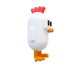

Right click or use the W button to make the chicken fly. Make sure to avoid the obstacles.

Tutorial



